**Project 100011:** [Map your mind](https://intranet.alxswe.com/projects/100011)

Presented by **Yassir BOUKHIMA**

________________________

**FLOW CHART**

**FUNCTION: Calculate a running sum**

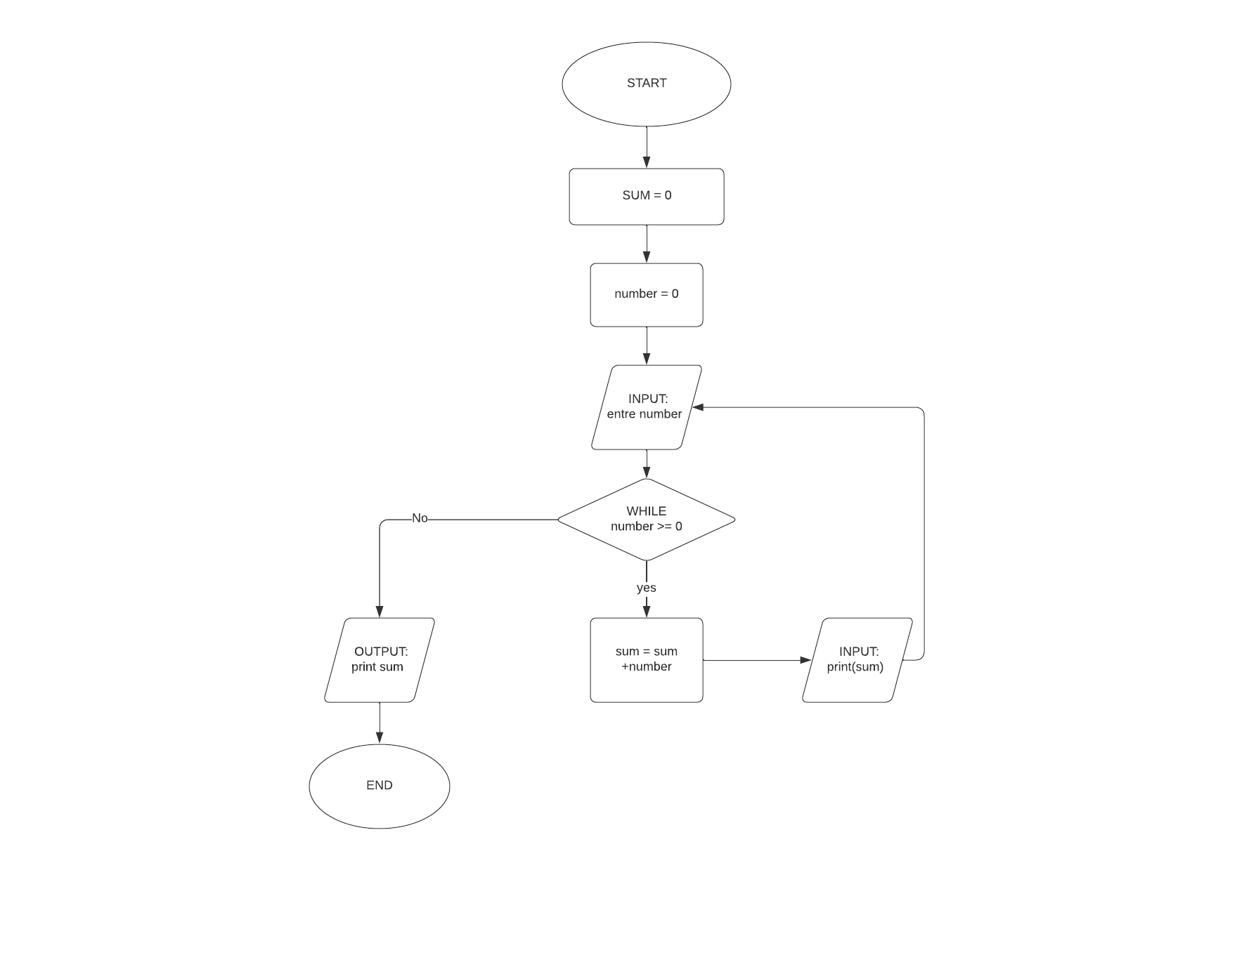

**pseudocode**

* START
* sum = 0
* number = 0
* INPUT: “entre number”
* WHILE (number >= 0)
  + - sum = sum + number
    - OUTPUT: print(sum)
    - INPUT: “entre number”
* OUTPUT print” sum”
* END

code in python (option)

number = 0

sum = 0

number =int(input())

while (number >= 0):

sum += number

print({sum})

number =int(input())

print({sum})